**Bug Report**

* **Attempt User Registration with Only a Dot in First and Last Name Fields Bug Report:**

1. **Title:** User Registration Allowed with Invalid Name (".")
2. **Description:** The system allows user registration when the "First name" and "Last name" fields contain only a single dot (".") which is not a valid name. This could lead to the creation of user accounts with nonsensical or incomplete names, potentially causing issues with user identification, communication, and data integrity.
3. **Steps to Reproduce:**
   * Navigate to the registration page.
   * Enter "." in the "First name" field.
   * Enter "." in the "Last name" field.
   * Enter a unique username.
   * Enter a valid password and confirm it.
   * Select a gender.
   * Click "Register".
   * Observe that the registration is successful.
4. **Expected Result:** The system should prevent user registration with a single dot (".") in the "First name" and "Last name" fields. An appropriate error message should be displayed, indicating that a valid name is required.
5. **Actual Result:** The registration is successful, and a user account is created with "." as the first name and "." as the last name.
6. **Environment:** (Please provide details like OS, browser, version, etc.)
7. **Severity:** High
8. **Priority:** High
9. **Attachments:** 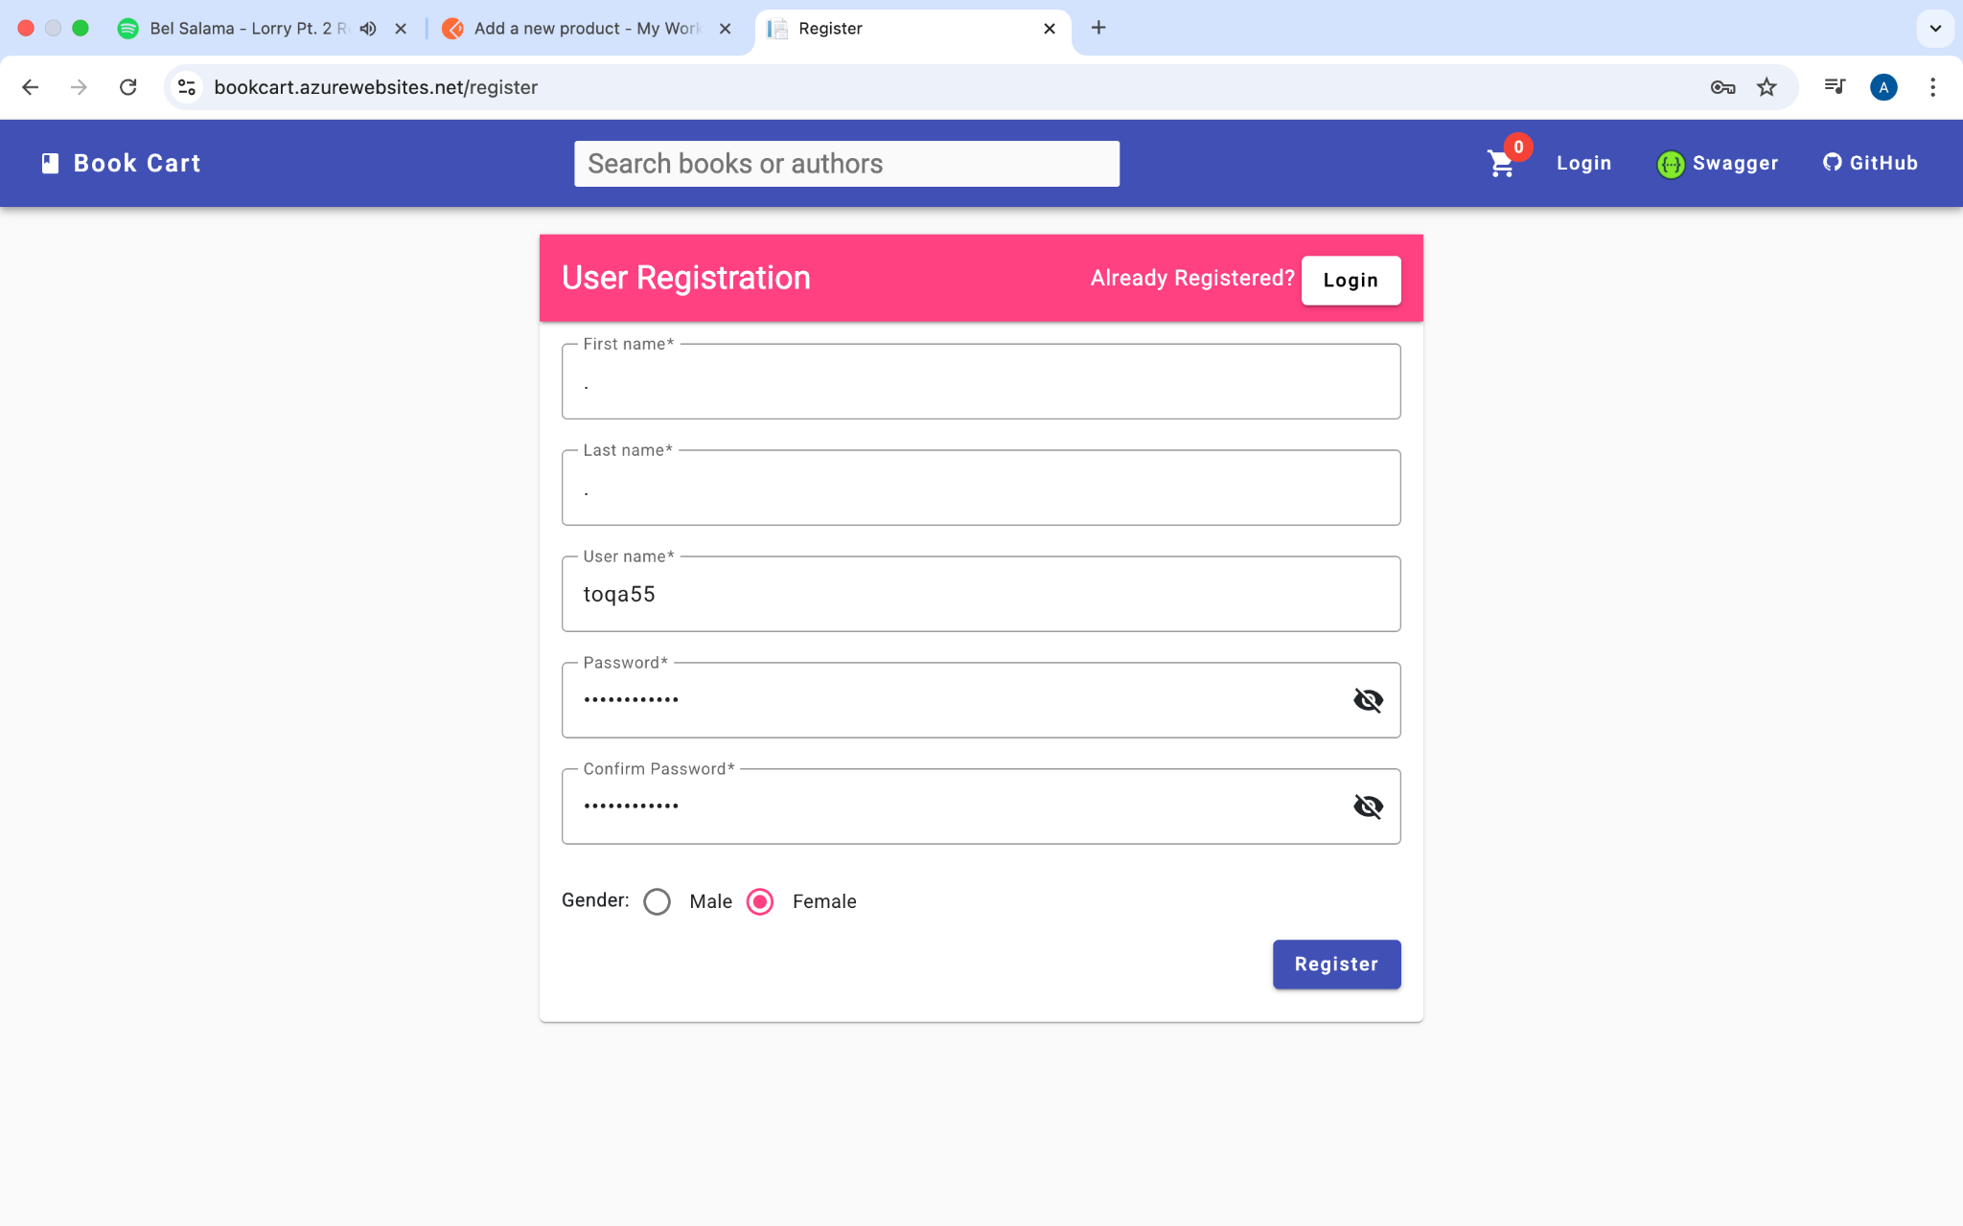

* **Verify First and Last Name Fields Accept Only Numbers, Dots, or Underscore Bug Report**

1. **Title:** Invalid Characters Allowed in First and Last Name Fields
2. **Description:** The "First name" and "Last name" fields accept inputs consisting only of numbers, a dot, and an underscore, which is not a valid format for a name. This could lead to the creation of user accounts with nonsensical or incomplete names, impacting data integrity and usability.
3. **Steps to Reproduce:**
   * Navigate to the registration page.
   * Enter "123._" in the "First name" field.
   * Enter "456._" in the "Last name" field.
   * Enter a unique username.
   * Enter a valid password and confirm it.
   * Select a gender.
   * Click "Register".
   * Observe that the registration is successful.
4. **Expected Result:** The system should prevent user registration with inputs like "123._" in the "First name" and "Last name" fields. It should only allow valid characters for names (e.g., letters, and possibly some special characters like hyphens or apostrophes). An appropriate error message should be displayed, indicating that a valid name is required.
5. **Actual Result:** The registration is successful, and a user account is created with the invalid characters in the first and last name fields.
6. **Environment:** (Please provide details like OS, browser, version, etc.)
7. **Severity:** Medium
8. **Priority:** Medium
9. **Attachments:** 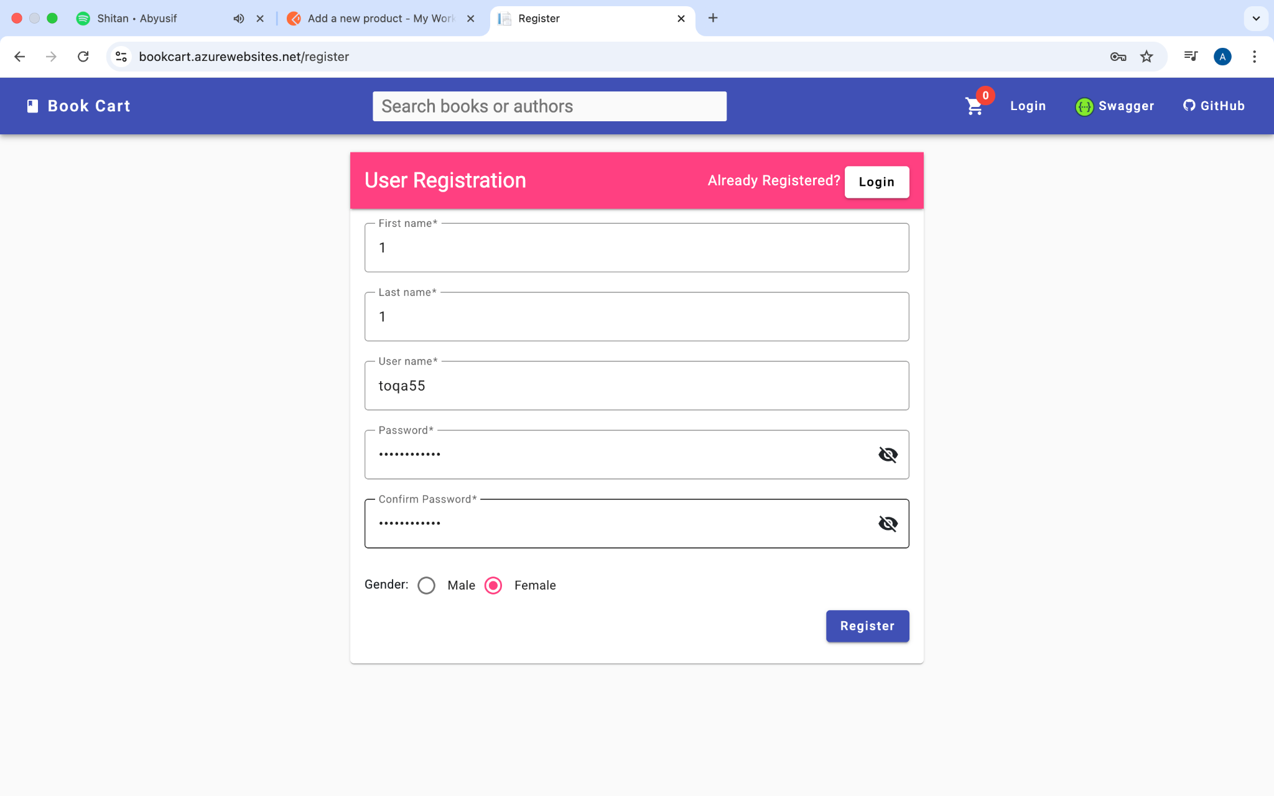

**- Attempt User Registration Without Choosing Gender Bug Report**

1. **Title:** Missing Gender Selection During Registration Fails Silently
2. **Description:** When attempting to register without selecting a gender, the registration fails, but no error message is displayed to inform the user that the "Gender" field is mandatory. This impacts usability as the user is not clearly informed about the missing required information.
3. **Steps to Reproduce:**
   * Navigate to the registration page.
   * Fill in all required fields (First Name, Last Name, Username, Password, Confirm Password).
   * Do not select either "Male" or "Female" for the Gender.
   * Click the "Register" button.
   * Observe that the registration fails without a specific error message for the "Gender" field.
4. **Expected Result:** The system should prevent user registration if the "Gender" field is not selected. An appropriate error message should be displayed, indicating that the "Gender" field is mandatory.
5. **Actual Result:** The registration fails, and a user account is not created. However, no error message is displayed to inform the user about the missing gender selection.
6. **Environment:** (Please provide details like OS, browser, version, etc.)
7. **Severity:** Medium
8. **Priority:** Medium
9. **Attachments:** 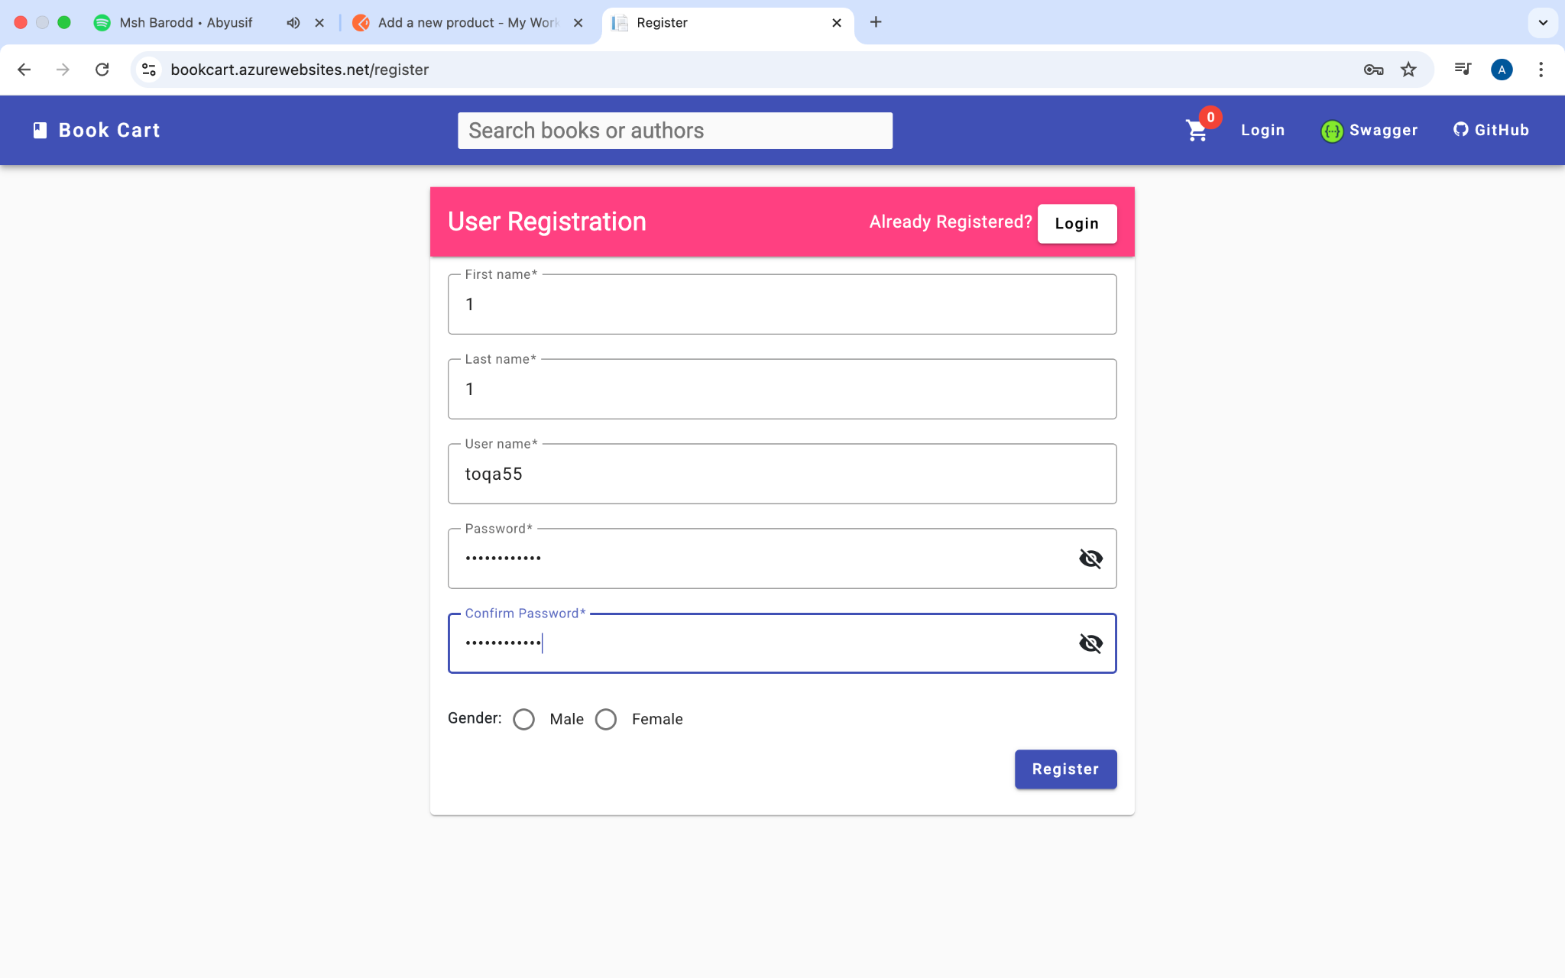

* **Login with Incorrect Username Bug Report**

1. **Title:** Incorrect Login Error Message Missing
2. **Description:** When attempting to log in with an incorrect username, the login fails, but no error message is displayed to inform the user about the incorrect credentials. This impacts usability as the user receives no feedback on why the login failed and may not know how to proceed.
3. **Steps to Reproduce:**
   * Navigate to the login page.
   * Enter an incorrect or non-existent username.
   * Enter any password.
   * Click the "Login" button.
   * Observe that the login fails, and no error message is shown.
4. **Expected Result:** The system should prevent login with an incorrect username. An appropriate error message should be displayed, such as "Invalid username" or "Incorrect credentials".
5. **Actual Result:** The login fails, and the user is not logged in. However, no error message is displayed to inform the user about the incorrect username.
6. **Environment:** (Please provide details like OS, browser, version, etc.)
7. **Severity:** High
8. **Priority:** High
9. **Attachments:** 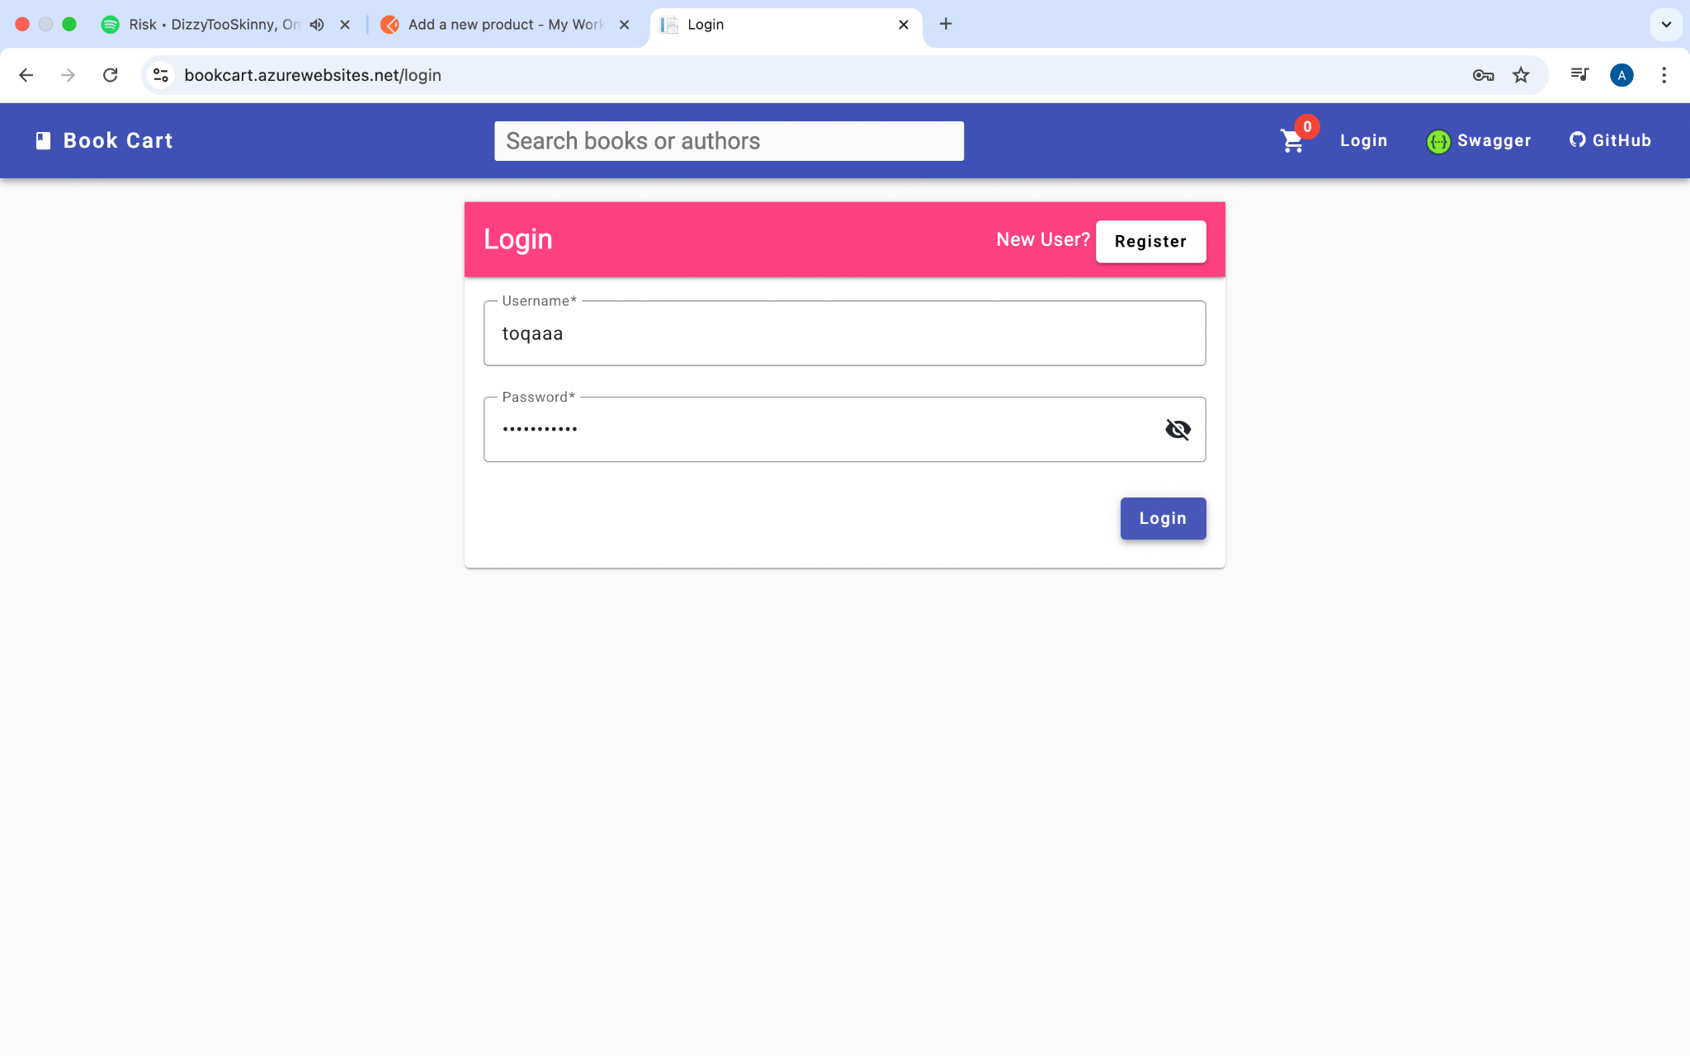

* **Case Sensitivity of Password Bug Report**

1. **Title:** Case Sensitivity of Password.
2. **Description:** The login system is not case-sensitive for passwords. Users can successfully log in even if the case of one or more letters in the entered password does not match the case of the letters in their actual password.
3. **Steps to Reproduce:** Log in with your correct username and password to ensure you have access. Log out. On the login page, enter your correct username. Enter your password, but change the case of at least one letter (e.g., if your password has a capital 'S', enter a lowercase 's'). Click the "Login" button. Observe that you are incorrectly logged in.
4. **Expected Result:** The system should only allow login with the correct username and password, matching the case of all letters. An error message should be displayed for incorrect credentials.
5. **Actual Result:** The user is logged in even when the password case does not match the stored password.
6. **Environment:** (Please provide details like OS, browser, version, etc.)
7. **Severity:** Critical - This is a significant security vulnerability. Password case sensitivity is a fundamental security practice. Failure to enforce it drastically reduces the security of user accounts, making them much easier to guess or brute-force.
8. **Priority:** High